

**Fundamentals of Programming**

**Name:** Muhammad Mubbashir Khan

**Section:** B

**Assignment no:** 1

**Task no: 1**

**Write a C++ program to display factors of a number using for loops**.

#include <iostream>

using namespace std;

int main()

{

int a, b;

cout<< "enter the positive number you want to take factors of: ";

cin>> a;

if(a<=0){

cout<<"please enter a valid number"<< endl;

}

else if(a>0){

cout<< "factors of " << a <<" are"<< endl;

for(int i=1;i<=a;i++){

if(a%i==0){

cout<<i << " ";

}

}

}

return 0;

}

**Output:**

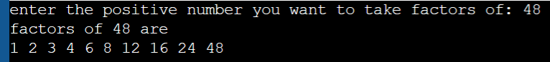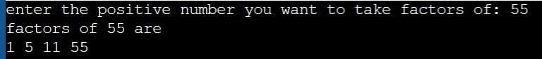

**Task no: 2**

**Write output to the following code**.

#include <iostream>

int main() {

int x = 5;

int y = 10;

if (x == 5)

if (y == 10)

std::cout << "x is 5 and y is 10" << std::endl;

else{

std::cout << "x is not 5" << std::endl;}

return 0;

}

**Output:**

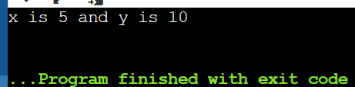

**Task no:3**

**Write a C++ program, take an integer value from user and check if it’s greater than 10 and less than equal to 20. Print 1 if yes and print 0 if no. Use appropriate datatype for output**

#include <iostream>

using namespace std;

int main()

{

int a;

cout<< "Enter a number: ";

cin >> a;

if(a>10 && a<=20){

cout<< "1";

}

else{

cout<< "0";

}

return 0;

}

**Output:**

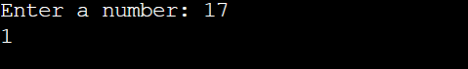

**Task no:4**

**Write a C++ program that uses a while loop to find the largest prime number less than a given positive integer N. Your program should take the value of N as input from the user and then find the largest prime number less than or equal to N. You are not allowed to use any library or pre-existing functions to check for prime numbers**.

#include <iostream>

using namespace std;

int main(){

int num,i, count=1;

cout<<"Please enter a valid positive integer: ";

cin>>num;

if(num<=0){

cout<<"Please enter a positive integer.";

} cout<<"The largest prime number less than the given positive integer is: ";

i=num-1;

while(i>=2){

count=1;

int j=2;

while(j*j<=i){

if(i%j==0){

count=0;

break;

}

j++;

}

if(count==1){

cout<<i<<" ";

break;

}

--i;

}

return 0;

}

**Output:**

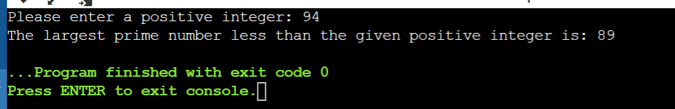

**Task no:5**

**Write a C++ program, take two string as input from user and check if both strings are equal or not. If they are equal make them unequal by rotating string. e.g., Hello is turned into olleH etc**

**Can be done by two methods**:

**Method 1:**

#include <iostream>

#include <string.h>

#include <algorithm>

using namespace std;

int main()

{

string a,b, c;

cout<< "Enter the first string: " ;

cin>> a;

cout<< "Enter the second string: " ;

cin>> b;

string revstr;

if(a==b){

cout<< "both strings are equal "<< endl;

string c="a";

reverse(a.begin(), a.end());

cout<<"rotated string is: " << a;

}

else{

cout<<"both string are not equal";

}

return 0;

}

**Method 2:**

#include <iostream>

#include <string>

using namespace std;

int main()

{

string a, b;

string rev = "";

cout<<"Enter first String: ";

cin>>a;

cout<<"Enter second String: ";

cin>>b;

if (a == b) {

for (int i = 0; i < a.length(); i++) {

rev= a[i] + rev;

}

cout<<"Strings are equal and Reversed string is: ";

cout<<rev;

}

else {

cout<<"Strings are unequal";

}

return 0;

}

**Output:**

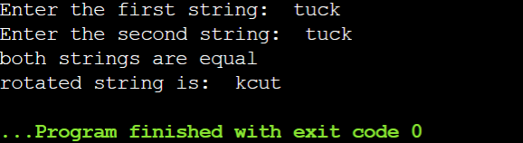

**Task no: 6**

**Perform division in C++ without / using for loops. You can use / only to display the final results. Your dividend must be greater than divisor**.

#include <iostream>

using namespace std;

double divide(double dividend, double divisor) {

if (divisor == 0) {

return -1;

}

if (dividend < divisor){

return 0;

}

double quotient = 0;

double remainder = dividend;

while (remainder >= divisor) {

remainder = remainder - divisor

quotient++;

}

return quotient;

}

int main() {

int dividend, divisor;

cout << "Enter the dividend: ";

cin >> dividend;

cout << "Enter the divisor: ";

cin >> divisor;

int result = divide(dividend, divisor);

if (result == -1) {

cout << "Error: Cannot divide by zero." << endl;

}

else {

cout << "The quotient is: " << result << endl;

}

return 0;

}

**Output:**

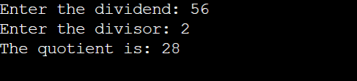

**Task no:7**

**Write a C++program for a string which may contain lowercase and uppercase characters. The task is to remove all duplicate characters from the string and find the resultant string.**

#include <iostream>

#include <string>

using namespace std;

string removeDuplicates(string s) {

int freq[256] = {0};

int index = 0;

for (int i = 0; i < s.length(); i++) {

int ascii = s[i];

if (freq[ascii] == 0) {

s[index] = s[i];

index++;

freq[ascii]++;

}

}

return s.substr(0, index);

}

int main() {

string input;

cout << "Enter a string: ";

getline(cin, input);

string output = removeDuplicates(input);

cout << "The string after removing duplicates is: " << output << endl;

return 0;

}

**Output:**

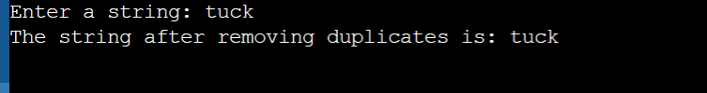

Task no:8

**Task no:8**

**Suppose an integer array a[5] = {1,2,3,4,5}. Add more elements to it and display them in C++.**

#include <iostream>

using namespace std;

int main() {

int a[5] = {1, 2, 3, 4, 5};

cout << "The original array is: ";

for (int i = 0; i < 5; i++) {

cout << a[i] << " ";

}

cout << endl;

int b[10];

for (int i = 0; i < 5; i++) {

b[i] = a[i];

}

b[5] = 6;

b[6] = 7;

b[7] = 8;

b[8] = 9;

b[9] = 10;

cout << "The new array is: ";

for (int i = 0; i < 10; i++) {

cout << b[i] << " ";

}

cout << endl;

return 0;

}

**Output:**

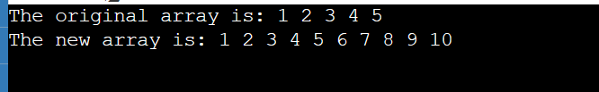

**Task no:9**

**Given an integer array and an integer X. Find if there’s a triplet in the array which sums up to the given integer X**.

#include <iostream>

using namespace std;

bool findTriplet(int arr[], int n, int X) {

for (int i = 0; i < n - 1; i++) {

for (int j = i + 1; j < n; j++) {

if (arr[i] > arr[j]) {

swap(arr[i], arr[j]);

}

}

}

for (int i = 0; i < n - 2; i++) {

int left = i + 1;

int right = n - 1;

while (left < right) {

int sum = arr[i] + arr[left] + arr[right];

if (sum == X) {

return true;

} else if (sum < X) {

left++;

} else {

right--;

}

}

}

return false;

}

void printArray(int arr[], int n) {

for (int i = 0; i < n; i++) {

cout << arr[i] << " ";

}

cout << endl;

}

int main() {

int n;

int X;

cout << "Enter the size of the array: ";

cin >> n;

int arr[n];

cout << "Enter the elements of the array: ";

for (int i = 0; i < n; i++) {

cin >> arr[i];

}

cout << "Enter the target sum: ";

cin >> X;

cout << "The array is: ";

printArray(arr, n);

bool result = findTriplet(arr, n, X);

if (result) {

cout << "There is a triplet in the array that sums up to " << X << endl;

} else {

cout << "There is no triplet in the array that sums up to " << X << endl;

}

return 0;

}

**output:**

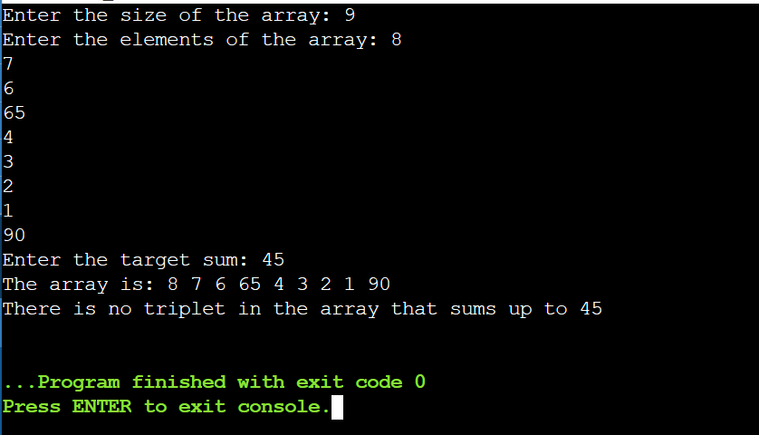

**Task no: 10**

Implement Bubble Sort on an array of 6 integers.

#include <iostream>

using namespace std;

void swap(int *a, int *b) {

int temp = *a;

*a = *b;

*b = temp;

}

void bubbleSort(int arr[], int n) {

for (int i = 0; i < n - 1; i++) {

for (int j = 0; j < n - i - 1; j++) {

if (arr[j] > arr[j + 1]) {

swap(&arr[j], &arr[j + 1]);

}

}

}

}

void printArray(int arr[], int n) {

for (int i = 0; i < n; i++) {

cout << arr[i] << " ";

}

cout << endl;

}

int main() {

int arr[] = {64, 34, 25, 12, 22, 11};

int n = sizeof(arr) / sizeof(arr[0]);

cout << "Original array: ";

printArray(arr, n);

bubbleSort(arr, n);

cout << "Sorted array: ";

printArray(arr,n)

return 0;

}

**Output:**

